Unit #3: Investigating Quadratics (9 days + 1 jazz day + 1 summative evaluation day)

BIG Ideas:

- Developing strategies for determining the zeroes of quadratic functions
- Making connections between the meaning of zeros in context
- quadratic data can be modeled using algebraic techniques

DAY | Lesson Title & Description | 2P | 2D | Expectations |  | Teaching/Assessment Notes and Curriculum Sample Problems
1 | The Zero Connection  - students explore the connections between the x-intercepts and the roots of a quadratic equation  Lesson Included | C | R | QF1.05  ✓ | determine, through investigation, and describe the connection between the factors used in solving a quadratic equation and the x-intercepts of the corresponding quadratic relation | Sample problem: The profit, P, of a video company, in thousands of dollars, is given by P = –5x² + 550x – 5000, where x is the amount spent on advertising, in thousands of dollars. Determine, by factoring and by graphing, the amount spent on advertising that will result in a profit of $0. Describe the connection between the two strategies.  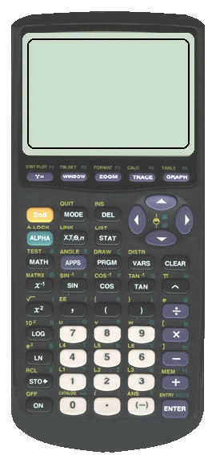
2 | The simple Life  - students explore different representations for expanding and simplifying quadratic expressions  Lesson Included | C | C | QF1.02  ✓ | represent situations (e.g., the area of a picture frame of variable width) using quadratic expressions in one variable, and expand and simplify quadratic expressions in one variable [e.g., 2x(x + 4)-(x+3)² ];* | *The knowledge and skills described in this expectation may initially require the use of a variety of learning tools (e.g., computer algebra systems, algebra tiles, grid paper.  
3,4 | Factoring Quadratics  - Factor both simple and complex trinomials  - Factor, through exploration, different types of trinomials | Have only done simple trinomials | C | QF1.03  ✓ | factor quadratic expressions in one variable, including those for which a≠1 (e.g., 3x²+ 13x – 10), differences of squares (e.g.,4x² – 25), and perfect square trinomials (e.g., 9x² + 24x + 16), by selecting and applying an appropriate strategy ( | Sample problem: Factor 2x² – 12x + 10.);  The knowledge and skills described in this expectation may initially require the use of a variety of learning tools (e.g., computer algebra systems, algebra tiles, grid paper.
5,6 | Solving Quadratic Equations  - Solve equations by factoring | N | R | QF1.04  ✓ | solve quadratic equations by selecting and applying a factoring strategy;
7 | Back to the Future  - connect graphic, algebraic and written representations  - determine solutions to problems in context involving applications of quadratic functions  Lesson Included | C | C | QF3.03  ✓ | solve problems arising from real-world applications, given the algebraic representation of a quadratic function (e.g., given the equation of a quadratic function representing the height of a ball over elapsed time, answer questions that involve the maximum height of the ball, the length of time needed for the ball to touch the ground, and the time interval when the ball is higher than a given measurement) [ | Sample problem: In a DC electrical circuit, the relationship between the power used by a device, P (in watts,W), the electric potential difference (voltage), V (in volts,V ), the current, I (in amperes, A), and the resistance, R (in ohms,Ω), is represented by the formula P = IV – I² R. Represent graphically and algebraically the relationship between the power and the current when the electric potential difference is 24 V and the resistance is 1.5 Ω. Determine the current needed in order for the device to use the maximum amount of power.].
8 | Exploring Quadratic Phenomena  - Collect and explore quadratic data either through experiment or using pre-made data | C | C | QF3.01  ✓ | collect data that can be modelled as a quadratic function, through investigation with and without technology, from primary sources, using a variety of tools (e.g., concrete materials; measurement tools such as measuring tapes, electronic probes, motion sensors), or from secondary sources (e.g., websites such as Statistics Canada, E-STAT), and graph the data; | Sample problem: When a 3 x 3 x 3 cube made up of 1 x 1 x 1 cubes is dipped into red paint, 6 of the smaller cubes will have 1 face painted. Investigate the number of smaller cubes with 1 face painted as a function of the edge length of the larger cube, and graph the function.
9 | Math's Next Top Model  - students will determine an appropriate quadratic model using x-intercepts and one point  Lesson Included | N | N | QF3.02  ✓ | determine, through investigation using a variety of strategies (e.g., applying properties of quadratic functions such as the x-intercepts and the vertex; using transformations), the equation of the quadratic function that best models a suitable data set graphed on a scatter plot, and compare this equation to the equation of a curve of best fit generated with technology (e.g., graphing software, graphing calculator); | Suggestion…..Bouncing ball…students can find the equation using the x-intercepts and 1 point
10 | Review Day (Jazz Day)
11 | Summative Unit Evaluation

Unit 3 : Day 1 : The Zero Connections |  |  | MCF 3M
Minds On: 10 |  | Description/Learning Goals  - Explore the connection between the x-intercepts of a quadratic function and the roots/zeros of a quadratic equation | Materials  - BLM 3.1.1 – BLM 3.1.5  - Markers for game (e.g., highlighters, bingo chips)  - Paper clips  - Graphing calculators
Action: 40
Consolidate:25
Total = 75 min
Assessment
Opportunities
 | Minds On… | Partners → Pair Share  Describe the structure of the pair share activity. In pairs, students work through BLM 3.1.1.  An alternate introductory activity is available at the Texas Instruments Activity Exchange (a useable pdf file is found at this site) relating linear factors and zeros. http://education.ti.com/educationportal/activityexchange/Activity.do?cid=US&aId=6328  Whole Class → Discussion  Have students lead discussion. What connections did they see?  Define solutions to #3 as 'zeros' of the equations.  Explain how to play the games (BLM 3.1.2 and BLM 3.1.3) – see teacher notes for instructions (BLM 3.1.5) |  |  | Literacy strategy: During the Minds On, a Pair-Share is used to familiarize students with the terminology they will be using in the rest of the lesson.  Note:  BLM 3.1.2 could be used again for unit 4, lesson 1 when introducing the significance of “a”.
 | Action! | Pairs or Small Groups → Investigation  Students work in pairs to play games using BLM 3.1.2 and BLM 3.1.3.  Students will have approximately 15 minutes for each game.
 | Consolidate Debrief | Whole Class → Discussion  The teacher should direct the students to examine the connections made in the two games.  Possible Guiding Questions:  - How could you determine the x-intercepts/zeros of a quadratic function?  - What are the roots of a quadratic equation?  - How are quadratic functions and equations the same? Different?  Mathematical Process Focus: Connecting (Students will make connections between different representations e.g., numeric, graphical and algebraic.)  Individual → Practice  Work through handout BLM 3.1.4.
Concept Practice  Exploration |  | Home Activity or Further Classroom Consolidation  Complete BLM 3.1.4.  Extension: Ask students to think about how they would possibly match the graphs of the functions given in BLM 3.1.2.

3.1.1 Pair Share

Partner A will explain to partner B how you would answer question #1 in column A. Then partner B will explain to partner A how to answer question #1 in column B. The process is repeated for each question number.
Partner A | Partner B
1. What is the x-intercept for the function?  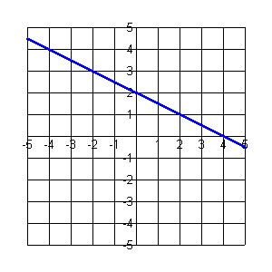 | 1. What is the x-intercept for the function?  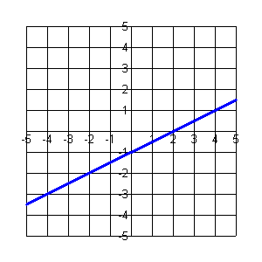
2. Sketch a linear function with an  x-intercept of -3.  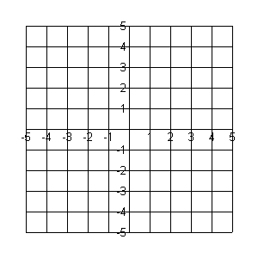 | 2. Sketch a linear function with an  x-intercept of 1.
3. Solve the equation $x+6=0$. | 3. Solve the equation $x−5=0$.
4. Given $f(x)=x+6$, evaluate $f(−6)$. | 4. Given $f(x)=x−5$, evaluate $f(5)$.
5. Graph the function $y=x+6$.  State the x-intercept. | 4. Graph the function $y=x−5$.  State the x-intercept.

3.1.2 As a matter of “fact”ors…

Match the graphs with their factors.
Reminder: Only the x-intercepts need to match (do not worry about the direction and/or shape of the graph).
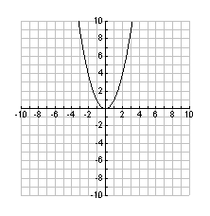  $$y=\underline{ }\left( \right)\left( \right)$$ | 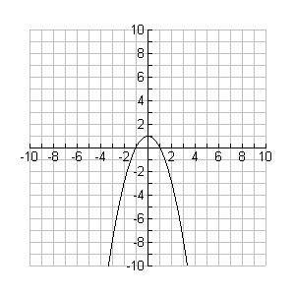  $$y=\underline{ }\left( \right)\left( \right)$$ | 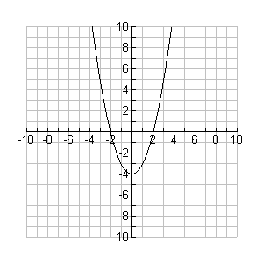  $$y=\underline{ }\left( \right)\left( \right)$$ | 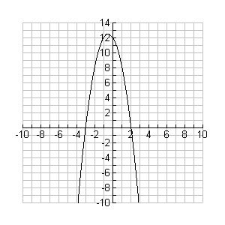  $$y=\underline{ }\left( \right)\left( \right)$$ | 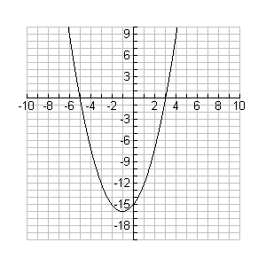  $$y=\underline{ }\left( \right)\left( \right)$$
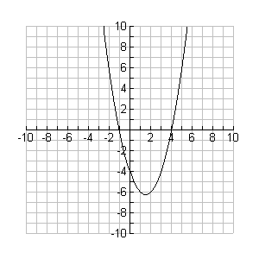  $$y=\underline{ }\left( \right)\left( \right)$$ | 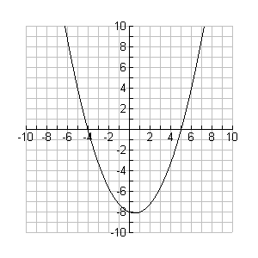  $$y=\underline{ }\left( \right)\left( \right)$$ | 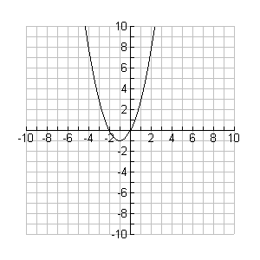  $$y=\underline{ }\left( \right)\left( \right)$$ | 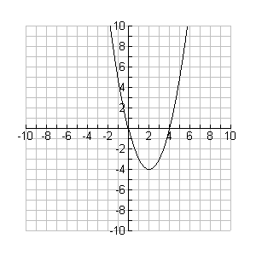  $$y=\underline{ }\left( \right)\left( \right)$$ | 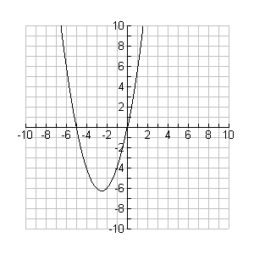  $$y=\underline{ }\left( \right)\left( \right)$$
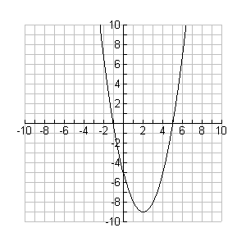$y=\underline{ }\left( \right)\left( \right)$ | 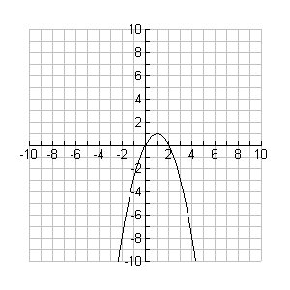  $$y=\underline{ }\left( \right)\left( \right)$$ | 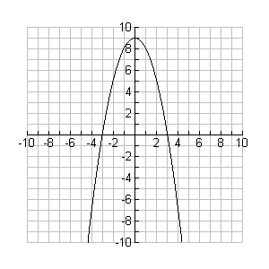  $$y=\underline{ }\left( \right)\left( \right)$$ | 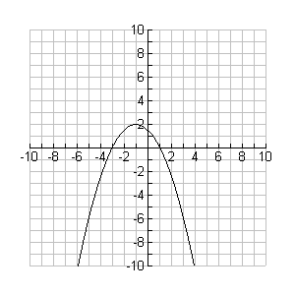  $$y=\underline{ }\left( \right)\left( \right)$$ | 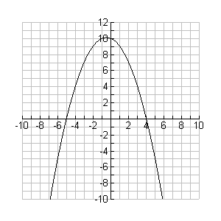  $$y=\underline{ }\left( \right)\left( \right)$$
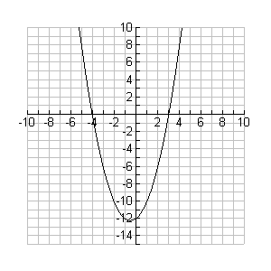  $$y=\underline{ }\left( \right)\left( \right)$$ | 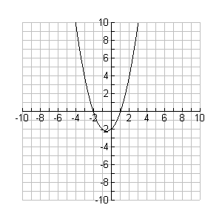  $$y=\underline{ }\left( \right)\left( \right)$$ | 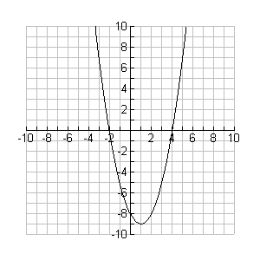  $$y=\underline{ }\left( \right)\left( \right)$$ | 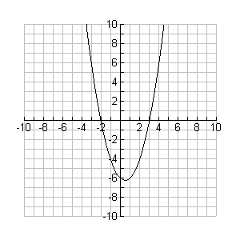  $$y=\underline{ }\left( \right)\left( \right)$$ | 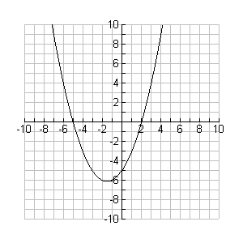  $$y=\underline{ }\left( \right)\left( \right)$$
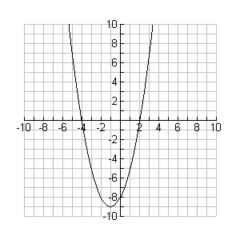  $$y=\underline{ }\left( \right)\left( \right)$$ | 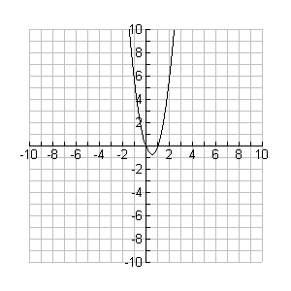  $$y=\underline{ }\left( \right)\left( \right)$$ | 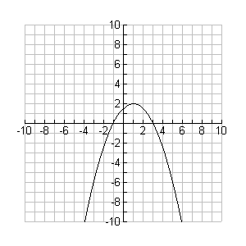  $$y=\underline{ }\left( \right)\left( \right)$$ | 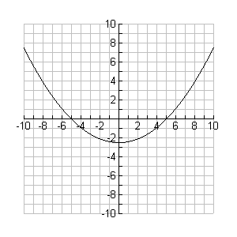  $$y=\underline{ }\left( \right)\left( \right)$$ | 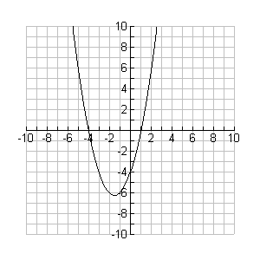  $$y=\underline{ }\left( \right)\left( \right)$$
x | x + 1 | x + 2 | x + 3 | x + 4 | x + 5 |  | x | x - 1 | x - 2 | x - 3 | x - 4 | x - 5

3.1.3 “Zero”ing In

Match the functions with their x-intercepts.
$$y=x^{2}$$ | $$y=\left(4x+1\right)\left(2x−3\right)$$ | $$y=\left(4x+1\right)\left(2x−1\right)$$ | $$y=x(2x+3)$$ | $$y=\left(2x+3\right)\left(2x−3\right)$$
$$y=\left(x−2\right)\left(x+2\right)$$ | $$y=\left(4x−1\right)\left(2x+1\right)$$ | $$y=x(2x−1)$$ | $$y=\left(4x−3\right)\left(2x+3\right)$$ | $$y=x(2x−3)$$
$$y=\left(4x−1\right)\left(4x+3\right)$$ | $$y=x(x−2)$$ | $$y=\left(2x−3\right)\left(4x+3\right)$$ | $$y=\left(4x−1\right)\left(2x+3\right)$$ | $$y=\left(2x+1\right)\left(4x−3\right)$$
$$y=x(4x−3)$$ | $$y=x(2x+1)$$ | $$y=\left(4x+1\right)\left(4x−3\right)$$ | $$y=x(4x+1)$$ | $$y=\left(2x−3\right)\left(2x+1\right)$$
$$y=\left(2x+3\right)\left(2x−1\right)$$ | $$y=x(x+2)$$ | $$y=\left(4x+3\right)\left(2x−1\right)$$ | $$y=x(4x−1)$$ | $$y=x(4x+3)$$

0 | $$\frac{1}{4}$$ | $$\frac{1}{2}$$ | $$\frac{3}{4}$$ | $$\frac{3}{2}$$ | 2 |  | 0 | $$−\frac{1}{4}$$ | $$−\frac{1}{2}$$ | $$−\frac{3}{4}$$ | $$−\frac{3}{2}$$ | -2

3.1.4 Quadratic Equation vs. Quadratic Function

Complete the following table. The zeros and roots must be the same within a row.
Algebraic Model Of Quadratic Function | Graphical Model Of Quadratic Function | x-intercepts or zeros | Equation and  Roots Of Equation
 | 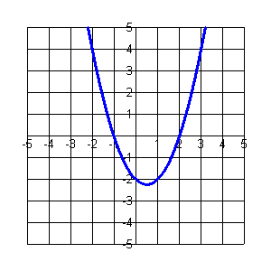 |  | Equation:  $$0=\left(x \right)\left(x \right)$$  Roots:  $x=$ and $x=$
Equation:
$$0=\left(x+2\right)\left(x−1\right)$$

Roots:
$x=$ and $x=$
$$y=\left(x+4\right)\left(x−3\right)$$ |  |  | Equation:  $$0=\left(x \right)\left(x \right)$$  Roots:  $x=$ and $x=$
 |  | -3 and 5 | Equation:  $$0=\left(x \right)\left(x \right)$$  Roots:  $x=$ and $x=$
Equation:
$$0=\left( \right)\left( \right)$$

Roots:
$x= 4$ and $x= \frac{1}{2}$

3.1.4 Quadratic Equation vs. Quadratic Function (continued)

- On a separate piece of paper, compare quadratic functions and quadratic equations. Examine the table and generalize the similarities and differences within a row.

- Complete the following table.
Function | x-intercepts/zeros
- $$y=\left(5x+2\right)\left(x−2\right)$$
- $$y=\left(4x−1\right)\left(3x+2\right)$$
- $$y=\left(5x+3\right)\left(x−2\right)$$
- $$y=\left(3x\right)\left(x−4\right)$$
- $$y=\left(x+7\right)\left(5x+2\right)$$
 | -2 and 5
 | $\frac{1}{3}$ and $\frac{3}{4}$
 | 0 and $\frac{1}{3}$
 | 3

- Write quadratic equation with roots $x=−\frac{1}{5}$ and $x=\frac{3}{5}$.

- Sketch a quadratic function with zeros of 3 and -2.
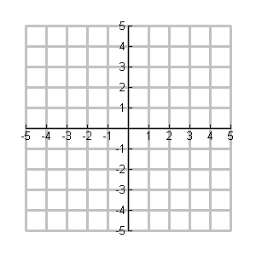
- Sketch a second quadratic function with the same zeros.

- How many possible quadratic functions could you sketch? Justify your answer.

- The profit of a video company, in thousands of dollars, for selling x videos is given by $P=−5\left(x−\text{10}\right)\left(x−\text{100}\right)$. Explain the significance of the
- x-intercepts for the graph of the profit function, and
- the roots of the equation if P = 0.

3.1.5 Teacher Instructions - BLM 3.1.2 and BLM 3.1.3

Rows 1 – 4 of BLM 3.1.2
$$y=\underline{ }\left( \right)\left( \right)$$ | $$y=\underline{ }\left( \right)\left( \right)$$ | $$y=\underline{ }\left( \right)\left( \right)$$ | $$y=\underline{ }\left( \right)\left( \right)$$ | $$y=\underline{ }\left( \right)\left( \right)$$
- First player places a paper clip under the factors (one on the left set and one on the right)

X | x + 1 | x + 2 | x + 3 | x + 4 | x + 5 |  | x | x - 1 | x - 2 | x - 3 | x - 4 | x – 5
 |  |  |  |  |  |  |  |  | Error: Reference source not found

- They then try to match with a function above that would cross the x-axis at the same place when defined in the form y = ___(x + 4)(x -2). It will be important to point out to students that the orientation and shape (stretch factor) of the match is irrelevant at this point.
- The other player will verify the choice using the graphing calculator [e.g., y = (x + 4)(x -2)]. A possible prompt for this would be “Does the function on the calculator cross at the same places as the function selected by your opponent?”
- If the selected function has the same x-intercepts, the player is able to put his/her marker on the game board and record the factors in the defining equation.

- The other player then moves one of the paper clips to try to gain an unclaimed spot on the board. The paper clip on the right must stay with the group of factors on the right and the paper clip on the left must stay with the group of factors on the left.

Reminder:
Students have not factored at this point in the course.

Unit 3 : Day 2 : The Simple Life |  |  |  | MCF 3M
Minds On: 10 |  | Description/Learning Goals  - Students will represent situations using quadratic expressions.  - Students expand and simplify quadratic expressions using computer algebra systems in a game scenario. |  | Materials  - BLM 3.2.1- BLM 3.2.3  - Algebra tiles  - Optional: Computer algebra systems
Action: 45
Consolidate:20
Total=75 min
Assessment
Opportunities
 | Minds On… | Pairs → Exploration  Each pair of students will be given a bag of algebra tiles that have been pre-packaged to form a factorable quadratic expression (ex. x² + 6x + 8; x² + 5x + 6, x² + 7x + 10). Students must arrange the tiles into a rectangle. Students will fill in BLM 3.2.1 once they have created their rectangle. |  | Once students have created their rectangles, introduce the names of the tiles (i.e. which tiles are the x-tiles, the x² tiles and the unit tiles) and instruct students to continue with BLM.  Virtual manipulatives can be found at http://nlvm.usu.edu/en/nav/topic_t_2.html or in the Sketches folder in GSP.  Make enough copies for each pair of students for BLM 3.2.3. The game board should be cut up into individual squares.
 | Action! | Individual → Exploration  Students will explore various tools for expanding binomial expressions.  The teacher will need to model the chart method for expanding binomials.  Example: Expand and simplify: (x + 4)(x -3)  (x + 4)(x -3)  = x² + 4x – 3x –12  = x² + x - 12  Pairs → A Simple Game  Students will use their expanding skills to complete the game. The object of the game is to piece together the original game board.  Mathematical Process of Lesson Focus: Connecting (Students will connect various representations of binomial multiplication).
 | Consolidate Debrief | Individual → Journal  Students will complete a journal entry response to the following question:  “Dora was absent from today’s lesson. She calls you on the phone and asks you to explain how to multiply two binomials. Write your explanation.”
Skill Drill |  | Home Activity or Further Classroom Consolidation  Appropriate selection of practice questions should be assigned for homework.
 | x | +4
x | x² | 4x
-3 | -3x | -12

3.2.1 "Wrecked"- tangles

Arrange the tiles in your bag into a rectangle. Draw the arrangement of the tiles in the space provided below.

Record the length, width and area of your rectangle.
Length | Width | Area

Trade your bag with another group and repeat the process.

Record the length, width and area of your rectangle.
Length | Width | Area

3.2.2 Expanding our Math Horizons

Using the Algebra Tiles

Expand and simplify the following expressions.
Expression | Expanded Form
$$x\left(x+1\right)$$
$$3\left(x+1\right)$$
$$\left(x+3\right)\left(x+1\right)$$
$$x\left(x+4\right)$$
$$4\left(x+4\right)$$
$${\left(x+4\right)}^{2}$$

Hypothesis
Explain how to expand $\left(x+3\right)\left(x+1\right)$ without using the tiles.

Test your hypothesis

Expand $\left(x+4\right)\left(x+5\right)$. Check with the algebra tiles.

Using the Chart Method

Expand and simplify $\left(x−4\right)\left(x+3\right)$. | Expand and simplify $\left(x+6\right)\left(x−8\right)$.

3.2.2 Expanding our (CAS Version)

Using the Computer Algebra System

Expand and simplify the following expressions.
Expression | Expanded Form
$$x\left(x+1\right)$$
$$3\left(x+1\right)$$
$$\left(x+3\right)\left(x+1\right)$$
$$2x\left(x+1\right)$$
$$5\left(x−4\right)$$
$$\left(2x+5\right)\left(x+1\right)$$
$$x\left(x+4\right)$$
$$4\left(x+4\right)$$
$$\left(x+4\right)\left(x+4\right)$$

Hypothesis
Explain how to expand $\left(x+3\right)\left(x+1\right)$ without using your calculator.

Test your hypothesis

Expand $\left(2x+1\right)\left(x−5\right)$. Check using your calculator.

3.2.3 A Simple Game

2x² + 13x - 15
3x² + 13x + 15
(3x + 1)(2x – 3)
6x² - 9x + 1
5y² – 12y + 4
x² + 3x - 13
3 + 4x - 15x²
(3 – 5x)(1 + 3x)
5x² + x - 4
(5x – 4)(x + 1)
5x² - x - 4
(5x + 4)(x - 1)
x² + 3x - 10
(5 + x)(x – 2)
x² - 81
(x + 3)(x – 3)
x² + 14x + 45
(x + 9)(x + 5)
2x² + 13x + 15
(2x + 3)(x + 5)
x² + 12x - 45
(x + 15)(x – 3)
x² + 3x - 28
(x + 7)(x – 4)
15x² + 3x - 12
3(5x – 4)(x + 1)
x² + 5x + 6
(x + 3)(x + 2)
x² - 9x - 10
(x + 1)(x – 10)
x² + 13x + 15
(x + 6)(x + 6)
(x – 6)(x – 6)
x² - 100
x² + 6x + 5
x² - 6
9x² - 1
(3x - 1)(3x + 1)
10x² - x - 3
(5x - 3)(2x + 1)
25x² - 36
(5x – 6)(5x + 6)
4x² – 9
(2x + 3)(2x – 3)
5y² – 12y + 4
(y - 2)(5y – 2)
x² + 3x - 40
(x + 8)(x – 5)
9x² - 6x + 1
(3x - 1)²
x² - 3x - 40
(x - 8)(x + 5)
10x² – 29x + 10
(2x – 5)(5x – 2)
9x² + 6x + 1
(3x + 1)²
10x² + x - 3
(5x + 3)(2x – 1)
x² + 13x + 40
(x + 8)(x + 5)
(5x - 3)(3x + 1)
6x² - 1
(5x + 1)(5x + 6)
(5x + 1)(5x + 1)

Unit 3 : Day 7 : Back to the Future |  |  |  | Grade 11 U/C
Minds On: 15 |  | Description/Learning Goals  - Connect the written description and the graphic and algebraic representations of a quadratic function  - Answer questions arising from real-world applications, given the algebraic representation of a quadratic function (QF3.03) |  | Materials  - BLM 3.7.1 (one set of graphs cut into individual cards and one scenario sheet for each pair in the class)  - BLM 3.7.2  - BLM 3.7.3  - Tape to post graphs  - Scenarios written on chart paper
Action: 40
Consolidate:20
Total=75 min
Assessment
Opportunities
 | Minds On… | Pairs → Think/Pair/Share Activity  Pairs will receive 4 cards of graphs and a sheet with the 4 scenarios from BLM 3.7.1. In partners, the students will match each graph to a particular scenario. Once students have all finished, they will then have 1 minute to tape their graphs under the appropriate scenario which has been written on chart paper and posted around the room.  Whole Class → Think/Pair/Share Activity  Review placement choices posted under each scenario. Have students share their justification for each posting, starting with those that are different. |  | Teachers can laminate the sets of 4 cards and the scenario sheets for re-use.  Literacy Strategy:  Four corners variation  Points labelled on the graphs in BLM 3.7.2 and 3.7.3 are the vertices.  Draw attention to the use of proper units in solutions, and discuss the domain and range for each scenario.
 | Action! | Pairs → Activity  Explain to students that they will determine which equation matches each of the two given graphs and scenarios on BLM 3.7.2.  Students will work in pairs to complete BLM 3.7.2.  Mathematical Process Focus: Connecting and representing (Students will connect and represent a variety of graphical, algebraic and written descriptions for real-world scenarios.)
 | Consolidate Debrief | Whole Class → Discussion  Discuss the rationale for determining which equation matches each graph.  Take up the answers to BLM 3.7.2, possibly by having students post an answer and explain it on the board. Allow students to share any different strategies that they used to answer the questions.
Concept Practice |  | Home Activity or Further Classroom Consolidation  Students will complete BLM 3.7.3 |  | The homework is similar to BLM 3.7.2 and uses the other two scenarios from class.

3.7.1 Back to the Future

Scenario | Graph
The holder places the football on the ground and holds it for the place kicker. The ball is kicked up in the air and lands down field.

A four-wheeled cart is held at the bottom of a ramp. It is given a gentle push so that is rolls part of the way up the ramp, slows, stops and then rolls back down the ramp. A motion detector is placed at the top of the ramp to detect the motion of the cart.

A student stands facing a motion detector. He quickly walks toward the detector, slows down, stops and then slowly walks away from the detector. He speeds up as he gets farther away from the detector.

A diver is on the diving platform at Wonder Mountain in Canada’s Wonderland. She jumps up and dives into the water at the base of the mountain.

3.7.1 Back to the Future (continued)
Time (seconds)
Distance (metres)
Time (seconds)
Distance (metres)
Time (seconds)
Distance (metres)
Time (seconds)
Distance (metres)



3.7.2 Back to the Future

Given the two equations 1. $d=0\text{.}2t^{2}−0\text{.}6t+0\text{.}\text{95}$
2. $d=−5t^{2}+\text{20}t$
The holder places the football on the ground and holds it for the place kicker. The ball is kicked up in the air and lands down field. | A four-wheeled cart is held at the bottom of a ramp. It is given a gentle push so that is rolls part of the way up the ramp, slows, stops and then rolls back down the ramp. A motion detector is placed at the top of the ramp to detect the motion of the cart.
Equation: | Equation:
- What is the height of the football at 0 seconds? | 1. How far is the cart from the detector at the start?
- What is the maximum height of the football? | 2. When is the cart closest to the detector?
- What is the height of the ball after 3 seconds? | 3. How far is the cart from the detector at 1 second?
- When is the football above 15m? | 4. How far does the cart travel before it stops and starts going back down the ramp?
(2 , 20)
●
(1.5 , 0.5)
●

3.7.3 Back to the Future

Given the two equations 1. $d=−3t^{2}+6t+\text{45}$
2. $d=0\text{.}\text{08}t^{2}−1\text{.}6t+9$
A student stands facing a motion detector. He quickly walks toward the detector, slows down, stops and then slowly walks away from the detector. He speeds up as he gets farther away from the detector. | A diver is on the diving platform at Wonder Mountain in Canada’s Wonderland. She jumps up and dives into the water at the base of the mountain.
Equation: | Equation:
1. How far is the student from the detector when he starts to walk? | 1. How high is the platform above the ground?
2. When is the student closest to the detector? | 2. What is the diver’s maximum height above the water?
3. What is his distance from the detector after 2 seconds? | 3. At what time is she 36m above the water?
4. When is he more than 3m from the detector? | 4. When is she less than 21m from the water?
(10 , 1)
●
(1 , 48)
●

Unit 3 : Day 9 : Math’s Next Top “Model” |  |  | MCF 3M
Minds On: 10 |  | Description/Learning Goals  - Determine an appropriate quadratic model for a scatter plot using intercepts and one point  - Compare this model to the curve of best fit generated using technology | Materials  - BLM 3.9.1  - BLM 3.9.2  - Graphing calculators
Action: 40
Consolidate:25
Total = 75 min
Assessment
Opportunities
 | Minds On… | Pairs → Exploration  In pairs, students will work through BLM 3.9.1 to explore the need for another point, in addition to the x-intercepts, to construct an accurate graphical model. |  |  | Data Sites that could be explored for modelling with quadratic functions:  http://education.ti.com/educationportal/sites/US/nonProductMulti/tii_datasites_math.html  http://teacherweb.com/ON/statistics/Math/photo5.stm  experimental ideas:  http://education.ti.com/educationportal/activityexchange  Browse by Subject : Math : Algebra I : Quadratic Functions (122 Activities)  Literacy strategy: During the Consolidation, students will be explaining their process in a journal entry.
 | Action! | Pairs or Small Groups → Investigation  Students will be reintroduced to the data generated for one of the activities from unit 2 lesson 2 (see BLM 2.2.7).  Students will be generating algebraic models using x-intercepts and graphing technology. They will then compare the two models through questions on BLM 3.9.2. A need for additional information to construct a better model will be determined and explored.  Mathematical Process Focus: Reflecting (Students will apply and extend knowledge to a new situation. They will also propose alternative approaches to a problem when considering the reasonableness of their answer.)
 | Consolidate Debrief | Individual → Journal Entry  Students will complete journal entry in BLM 3.9.2.  Whole Class → Discussion  Teacher lead discussion of a “class” process for determining an algebraic model for quadratic data.  Students should update their FRAME graphic organizer for quadratic functions with the algebraic models.
Concept Practice |  | Home Activity or Further Classroom Consolidation  Students should return to BLM 3.1.2 and determine the values for “a” for the functions and record these algebraic models. Select two of their algebraic representations and verify by selecting a fourth point.

3.9.1 Connecting the Dots

- With your partner, determine the maximum number of parabolas that could be drawn through the points given in each of the following graphs.

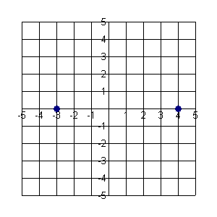
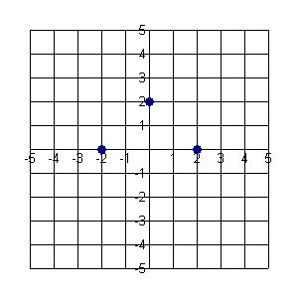
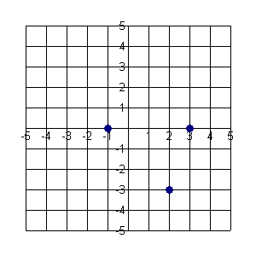
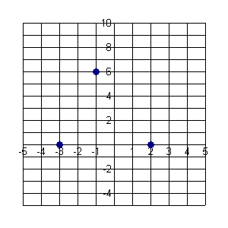
Graph A
Graph B
Graph C
Graph D

- Complete the following table:
Graph | Number Of Points | Number Of Possible Parabolas
A
B
C
D

- What is the minimum number of points required to define a unique parabola?
3.9.2 Math’s Next Top Model

Back to the Wall and Back

Here’s the data again from the activity we completed in Unit 2.

- Plot the data on the grid provided.
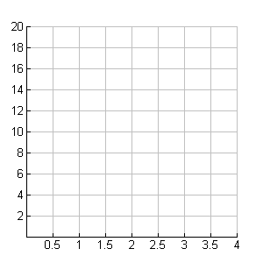
Time (s) | Distance from Motion Detector (m)
0 | 0
0.5 | 7
1 | 12
1.5 | 15
2 | 16
2.5 | 15
3 | 12
3.5 | 7
4 | 0

- Construct the curve of best fit.

- Using the intercepts, create an algebraic model for the data and record it in the box below.

f(x) = _____________________________

- Using your curve of best fit, determine the distance from the wall at 2.75 seconds.

- Using your algebraic model, determine the distance from the wall at 2.75 seconds.

- Reflect on the accuracy of your model in determining the distance at 2.75 seconds.

3.9.2 Math’s Next Top Model (continued)

- Enter the data into your graphing calculator and generate the regression that best fits the data. Record the regression equation below. Round the coefficients to the nearest whole number.

g(x) = ____________________________

- Using the regression model, determine the distance from the wall at 2.75 seconds.

- Reflect on the accuracy of the regression model in determining the distance at 2.75 seconds.

- In order to compare your model to the regression model we need to express them in the same form. Factor the regression model.

- Compare the factored form of the regression model to your model. What factor do you need to multiply your model by to make it match the regression model? (We will refer to this value as “a”.)

- As discussed earlier on we need at least three points to draw a parabola. Define your equation in this form: f(x) = a(x – zero)(x – zero).

f(x) = a(x - ___)(x - ____)

- Substitute any point from the data into the equation in #12 and solve for a. What do you notice?

- Pick another point and solve for a. Does the choice of point make a difference?
3.9.3 The Flight of a Golf Ball

The table below gives the height of a golf ball over time.
Time (seconds) | Height (m)
0 | 0
1 | 35
2 | 60
3 | 75
4 | 80
5 | 75
6 | 60
7 | 35
8 | 0

- Determine an algebraic model for the data.

h(t) = ___________________

- Verify your model by entering the data into your calculator and graphing your algebraic model. Rate how well your algebraic model fits the data using a scale of 0-1 (1 being a perfect fit). Justify your reasoning.

Journal Entry:

Summarize the process for finding an algebraic model for data that is quadratic.

Reflect:

Draw a parabola(s) whose equation cannot be determined using the process outlined.
